**Home Page:**

<html>

<head>

  <title> GENERATIONS OF COMPUTER </title>

</head>

<body bgcolor="grey">

  <h2> GENERATIONS OF COMPUTER </h2>

  The history of computer developement is often linked to the different generations of computing devices.Each of the

  five generations of computers

  is characterised by a major technical development that fundamentally changed the way computers operate, resulting in

  increasingly smaller,

  cheaper, more efficient and reliable computing devices

  <h3>GENERATIONS </h3>

  <li><a href = "first.html">FIRST GENERATION</a> </li> - (1940-1956)

  <li><a href = "second.html">SECOND GERNEATION</a> </li>- (1956-1963)

  <li><a href = "thrid.html">THIRD GERNEATION</a> </li> - (1964-1971)

  <li><a href = "fourth.html">FOURTH GERNEATION</a> </li>- (1972-present)

  <li><a href = "fifth.html">FIFTH GERNEATION</a> </li> - (present and beyond)

</body>

</html>

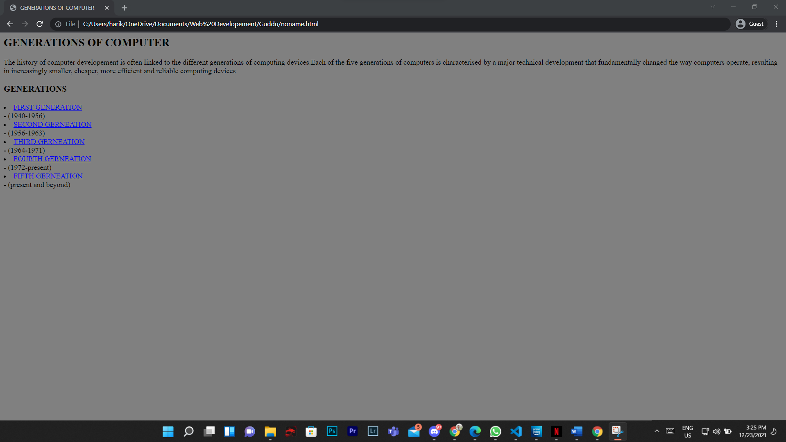

**First Generation:**

<!DOCTYPE html>

<html lang="en">

<head>

    <title>First Generation (1940-1956):Vaccum Tubes</title>

</head>

<body bgcolor="grey">

    <h1>First Generation (1940-1956):Vaccum Tubes</h1>

    <li>The first generation computers used vaccum tubes for circuitry and magnetic drums for

      memory.They were often enormous, taking up entire rooms</li>

    <li>First generation computers relied on machine language.</li>

    <li>They were expensive to operate, in addition to using a great deal of electricity, generated a lot of heat,which

      was often the case of

      malfuntions</li>

    <li>UNIVAC and ENIAC were examples of first-generation computing devices</li>

</body>

</html>

**Second Generation:**

<!DOCTYPE html>

<html lang="en">

<head>

    <title>Second Generation (1956-1963):Transistors</title>

</head>

<body bgcolor="grey">

    <h1>Second Generation (1956-1963):Transistors</h1>

    <li>Transistors replaced vaccum tubes and ushered in the second generation of computers.</li>

    <li>Second-generations computers still relied on punched cards for input and printouts for output</li>

    <li>Assembly languages were used, which allowed programmers to specify instructions in words. </li>

</body>

</html>

**Third Generation:**

<!DOCTYPE html>

<html lang="en">

<head>

    <title>Third Generation (1964-1971):Integrated Circuits</title>

</head>

<body bgcolor="grey">

    <h1>Third Generation (1964-1971):Integrated Circuits</h1>

    <li>Users interacted with third-generations computers through keyboards and monitors.</li>

    <li>For the first time, computers became accessible to a mass audience because they were smaller and cheaper than

      their predecessors</li>

    <li>The development of the integrated circuit was the hallmark of the third-generation computers.</li>

    <li>Transistors were miniaturised and placed on silicon chips, called semiconductors, which drastically increased the

      speed and efficiency

      of computers.</li>

</body>

</html>

**Fourth Generation:**

<!DOCTYPE html>

<html lang="en">

<head>

    <title>Fourth Generations (1972-Present):Microprocessors</title>

</head>

<body bgcolor="grey">

    <h1>Fourth Generations (1972-Present):Microprocessors</h1>

    <li>The microprocessor brought the fourth generation of computers as thousands of integrated circuits were built onto

      a single silicon chip.

      What in the first generation filled an entire room could now fit in the palm of hand.</li>

    <li>Fourth-generation computers also saw the development of GUI, the mouse and handheld devices.</li>

    <li> The intel 4004 chip, developed in 1971, located all the components of the computer-from the central processing

      unit and memory to input/

      output controls-on a single chip</li>

</body>

</html>

**Fifth Generation:**

<!DOCTYPE html>

<html lang="en">

<head>

    <title>Five Generations (present and beyond)</title>

</head>

<body bgcolor="grey">

    <h1>Five Generations (present and beyond)</h1>

    <h2> ARTIFICIAL INTELLIGENCE</h2>

    <li>Fifth-generations computing devices are based on artifical intelligence and voice recognition that are being used

      today.</li>

    <li>the use of parellel processing and superconductors is helping make artificial intelligence </li>

    <li>Quantum computation,molecular technology and nanotechnology will radically change the face of computers in years

      to come</li>

    <li>The goal of fifth-generation computing is to develop devices that respond to natural language input and are

      capable of learning and

      self-organisation</li>

</body>

</html>

